Barani Institute of Monitoring Sciences, Rawalpindi



Project Proposal

For

**SWMS : IoT-Based Smart Waste Monitoring System**

**Submitted By: Mr. Noman ul Hassan**

Student 1 : Muhammad Shoaib Qureshi

Registration No 1 : 20-Arid-3901

Student 2 : Muhammad Umer Kashmiri

Registration No 2 : 20-Arid-3912

Student 3 : Muhammad Fahad khan

Registration No 3 : 20-Arid-3875

**Supervised By:**

Mr. Noman ul Hassan

Mr. Hassan

Submission Date (16-October-2023)

(Original version)

Project ID: ___________

(ID will be assigned by coordinator)

* **Please select the appropriate category of your project** *(Select multiple if required)*

**A-**Desktop Application/Information System **🞏** **B-**Problem Solving and AI **🞏**

**C-**Web Application/Web Application based Information System. **🞏 D-**Simulation & Modeling **🞏**

**E-**Smartphone Application **🞏 F-**Smartphone Game **🞏**

**G-**Image Processing **🞏** **H-**Networks **🞏**

**I-** Other: IoT-Based Smart Waste Monitoring System **🗹**

**Group Members**

1. Student Name:Muhamm Shoaib Qureshi

Registration No: 20-Arid-3901

Class: BSCS-7

Section: A

Shift: Morning

Email:mhammadshoaibqureshi312@gmail.com

WhatsApp No:+92-301-5300312

1. Student Name:Muhammad Umer Kashmiri

Registration No: 20-Arid-3912

Class: BSCS-7

Section: A

Shift: Morning

Email:umerkashmiri04@gmail.com

WhatsApp No:+93-331-5012612

1. Student Name:Muhammad fahad Kahan

Registration No: 20-Arid-3875

Class: BSCS-7

Section: A

Shift: Morning

Email:fahad@gmail.com

WhatsApp No:+93-331-5012612

table of contents

1. Introduction 4

2. Literature Review 4

3. Problem Statement 4

4. Problem Solution 4

5. Advantages/Benefits of proposed system 4

6. Scope 4

7. Software Methodology 5

8. Tools and Technologies 5

9. Concepts 5

10. Intended Users 5

11. Mockups 6

12. Conclusion 6

## Introduction

The "IoT-Based Smart Waste Monitoring System" is a revolutionary initiative that harnesses Wi-Fi connectivity to provide real-time dustbin monitoring in our surrounding areas. By integrating weight and laser sensors, the system automatically triggers notifications when a dustbin reaches 85% capacity, optimizing waste Monitoring practices, reducing operational costs, and improving cleanliness. This project addresses the challenges of inefficient waste Monitoring and sub-optimal resource allocation, offering a data-driven, user-friendly solution with scalability for wider deployment.

## Literature Review

The existing waste Monitoring systems have limitations in real-time monitoring.

IoT in Smart Cities : [B. N. Silva, M. Khan, and K. Han] - Lacks real-time monitoring, resulting in irregular collections.

“Taking MQTT and NodeMcu to IOT: Communication in Internet of Things”, : Monika Kashyap, Vidushi Sharma, Neeti Guptam

Ajmal Khan, et.al, “IoT based smart waste bin to track dustbin and public complaint management system.” 8th IEEE International conference Communication System and Network Technology -2018, DOI10.1109/CSNT.2018.8820272.

## Problem Statement

The problem at hand pertains to the inefficient waste Monitoring practices prevalent in the areas, which result in sub-optimal resource allocation and increased operational costs. Traditional waste collection systems often lack the capability to monitor the fill levels of dustbins in real-time. This leads to challenges in maintaining cleanliness and hygiene in public spaces. The absence of automated notifications for waste collection authorities exacerbates the problem, causing delays in waste removal and a negative impact on surrounding environments.

## Problem Solution

Our project aims to implement an "IoT-Based Smart Waste Monitoring System" that integrates weight and laser sensors to monitor dustbin fullness in real-time. When a dustbin reaches 85% fullness, the system will automatically notify the relevant authorities. The project will employ Wi-Fi connectivity for data transmission, facilitating real-time dustbin monitoring. This solution seeks to revolutionize waste Monitoring practices, optimizing resource allocation, reducing operational costs, and significantly enhancing the overall quality of waste collection services. Furthermore, the re-implementation of such a system will provide valuable opportunities for skill development in the domains of IoT, Reactjs, and Laravel, ensuring the project's educational value.

## Advantages/Benefits of proposed system

* Real-time monitoring and timely waste collection.
* Reduced operational costs and optimized resource allocation.
* Improved hygiene and cleanliness in surrounding areas.
* Enhanced user experience with automated notifications.
* Scalable for wider deployment.
* Data-driven decision-making for waste management.

## Scope

The scope of the "IoT-Based Smart Waste Monitoring System" project includes the integration of Wi-Fi-enabled weight and laser sensors for real-time dustbin monitoring. Data Monitoring involves efficient storage and analysis of sensor data, while the user interface provides an interactive platform for users. Users can access real-time data, set notification triggers, and monitor waste collection. An automated notification system ensures that relevant authorities are promptly informed when a dustbin reaches 85% capacity, optimizing collection routes. Special features like secure Wi-Fi data transmission and real-time data analysis enhance the system's capabilities, providing valuable insights for data-driven decision-making in waste Monitoring practices.

**Modules of the project:**

The "IoT-Based Smart Waste Monitoring System" comprises several essential modules to ensure effective waste management.

**Sensor Integration and Data Collection Module:**

- **Special Features:** Secure data transmission, real-time data analysis.

- **Explanation:** This module integrates weight and laser sensors in dustbins for real-time monitoring. It securely transmits data to the central server and enables real-time data analysis.

**Data Analytics and Reporting Module:**

- **Special Features:** Real-time analytics, customizable reporting.

- **Explanation:** This module focuses on data analysis and reporting, providing insights from sensor data. It allows for real-time analytics and generates customizable reports for decision-making.

**User Monitoring and Notifications Module:**

- **Special Features:** User-specific customization, notification history.

- **Explanation:** This module manages user interactions and notifications. Users can customize their notification preferences and access real-time data. A notification history feature offers a review of past notifications.

**Centralized Data Repository and Analysis Module:**

- **Special Features:** Real-time data processing, historical data analysis.

- **Explanation:** This module centralizes data from sensors, securely storing it in a database. Real-time data processing allows for immediate analysis, while historical data analysis helps in long-term trend tracking.

**Waste Collection Optimization Module:**

- **Special Features:** Route optimization, resource allocation.

- **Explanation:** This module leverages data insights to optimize waste collection routes and efficiently allocate resources, ensuring a more cost-effective and systematic approach to waste management.

**User Interface and Dashboard Module:**

- **Special Features:** Real-time data visualization, user-friendly interface.

- **Explanation:** This module provides a user-friendly dashboard for stakeholders to access real-time data on dustbin fill levels and collection schedules, enhancing the overall user experience.

**Security and Access Control Module:**

- **Special Features:** Data encryption, role-based access.

- **Explanation** This module ensures data security by implementing encryption measures and role-based access control, safeguarding sensitive waste Monitoring information.

**Predictive Analytics and Forecasting Module (Future Enhancement):**

- **Special Features:** Future trend prediction, proactive planning.

- **Explanation**: This prospective module will utilize predictive analytics to forecast future waste generation patterns, assisting in proactive waste Monitoring planning.

These modules work collaboratively to create a robust and efficient waste Monitoring system, combining real-time data monitoring, data analysis, and user-friendly features to improve overall waste Monitoring practices.

## Software Methodology

The "IoT-Based Smart Waste Monitoring System" will employ the Agile methodology, featuring iterative development in short sprints. This approach encourages continuous stakeholder feedback, close team collaboration, and adaptability to changing requirements. Testing is integrated into each sprint, ensuring system reliability. The user-centric focus aligns the system with user needs, and transparency keeps stakeholders informed. This Agile approach enables efficient development and adaptation as the project progresses..

## Tools and Technologies

|  |  |  |
| --- | --- | --- |
| **Tools**  **And**  **Technologies** | **Tools** | **Version** |
| VS Code | 1.78.2.0 |
| React.js | 2023 |
| Laravel | 10 |
| Weight Sensor | 2022 |
| Laser Sensor | 2022 |
| Wifi-connectivity |  |
|  | 2.0.5 |
| **Technology** | **Version** |
| JavaScript | 6.0 |
| PHP | 2011 |
| Html | 5 |
| IoT-Protocols | 2023 |
| Wifi Networking | - |
| CSS(Boostrape) | 2023 |

## Concepts

**IoT Integration:** Understanding how to integrate Internet of Things (IoT) devices, such as sensors, into a system for real-time data collection and monitoring.

**Real-Time Data Analysis:** Learning how to process and analyze data in real-time, extracting meaningful insights from the continuously generated data to inform decision-making.

**Secure Data Transmission:** Implementing data encryption and secure data transmission protocols to protect the integrity and confidentiality of the data being collected and shared.

**User-Centric Design:** Focusing on user needs and preferences to create a user-friendly interface and customizable notification system for a seamless user experience.

## Intended Users

* **Municipal authorities:** These users will oversee and manage waste collection operations, relying on the system's real-time data and insights for efficient resource allocation and route optimization.
* **Waste collection teams:** Collection teams responsible for waste pickup will use the system to plan and execute collection activities, ensuring they are well-informed about dustbin fill levels and optimized routes.
* **Residents:** The system will empower residents by allowing them to access real-time information about waste collection schedules, ensuring they know when to prepare and set out their waste for collection.
* **System Administrators:** Administrators will manage and maintain the system, handling user accounts, system configurations, and ensuring data security.
* **Developers and Technical Support:** The technical team will develop and support the system, ensuring its smooth operation and addressing technical issues.

## Mockups

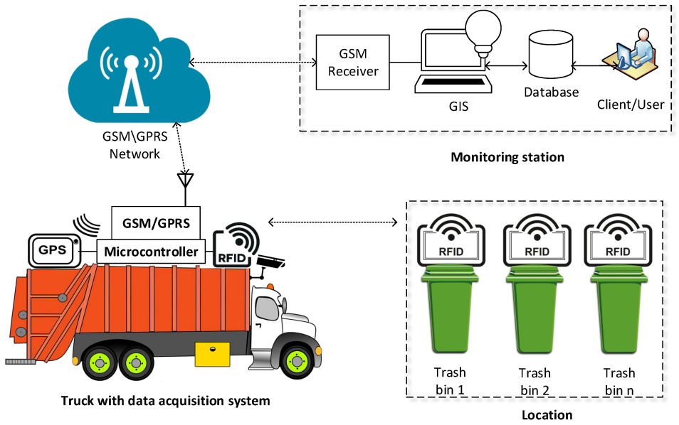

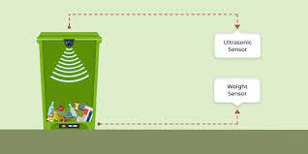

## Timeline

November

2023

Requirement

December

2023

Analysis

.

Febraury

2023

Design

April

2023

Development

May

2023

Testing &

Deployment

June

2023

Final

Evaluation

## Conclusion

In conclusion, the "IoT-Based Smart Waste Monitoring System" is a transformative solution that leverages IoT technology, real-time data analysis, and user-friendly interfaces to enhance waste collection and monitoring in surrounding and areas. This project, guided by Agile methodology, promises increased efficiency, optimized resource allocation, and improved user experiences. By providing secure data transmission, real-time analytics, and user-specific notifications, it equips municipal authorities, waste collection teams, and residents with the tools to make informed decisions and contribute to more sustainable waste Monitoring practices, ultimately fostering cleaner and greener surrounding environments.

## References

1. **Smith** and B. **Johnson**. "Smart Waste Management System." WasteTech Solutions. [https://www.wastetechsolutions.com/smart-waste-management](https://www.wastetechsolutions.com/smart-waste-management" \t "https://chat.openai.com/c/_new).

Accessed: October 14, 2022.

**Evaluation Page**

**Evaluator 1 Comments:**____________________________________________________________

_________________________________________________________________________________

_________________________________________________________________________________

_________________________________________________________________________________

_________________________________________________________________________________

_________________________________________________________________________________

_____________

Signatures

**Evaluator 2 Comments:**____________________________________________________________

_________________________________________________________________________________

_________________________________________________________________________________

_________________________________________________________________________________

_________________________________________________________________________________

_________________________________________________________________________________

_____________

Signatures

**Project Coordinator Comments**_____________________________________________________

_________________________________________________________________________________

_________________________________________________________________________________

_________________________________________________________________________________

_________________________________________________________________________________

_________________________________________________________________________________

_________________________________________________________________________________

_____________

Signatures